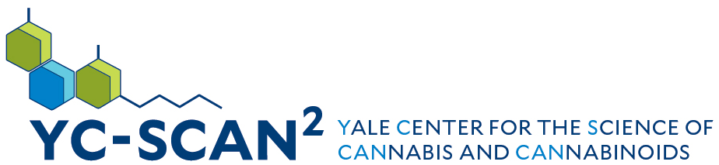
Yale University
Summer Student Volunteer Program
A hub for groundbreaking research, dissemination of information, and education in the science of cannabis and cannabinoid science.
Yale Center for the Science of Cannabis and Cannabinoids
3-13-2026

Overview:
Thank you for your interest in volunteering at the Yale Center for the Science of Cannabis and Cannabinoids! Our Summer Student Volunteer Program was created to give medical school students an opportunity to experience working at a research facility that specializes in psychiatry and provide an introduction to mental health research. We strive to pair students with projects across the center to allow students the opportunity to volunteer, providing necessary services for the lab while also learning about psychiatric clinical research.
Please note, this is not a job shadow or internship experience. Students in this Summer Volunteer Program will be assisting with study observation, phone screenings, follow up calls, completing administration and clerical duties among other miscellaneous tasks as assigned by their department manager.
Although this is not a job shadowing experience, students are expected to adhere to a level of professionalism equivalent to a job or classroom experience. This includes, but not limited to, professional attire, behavior and conduct. Please read the below requirements for participation clearly. Due to the volume of applicants, please note exceptions cannot be made.

Criteria
- Applicants must be referred by a Yale University professor, Physician or Employee.
- Applicants must attest that they have read the program requirements document prior to completing an application.
- Applicants must be age 18 at the start of the program. We have separate opportunities available for any non Yale University enrolled students. Please email yalecannabisresearch@yale.edu for more information.
- Applicants must be available for a minimum six of the eight weeks of the program. The program runs June 1 – August 28, 2026.
- Any vacation time must be submitted prior to May 15, 2026 so that we may plan accordingly. Time off cannot exceed two weeks of the program. Those unable to meet the minimum requirements will not be eligible to participate.
- Volunteers must have reliable transportation for the hours that they are scheduled. We cannot accommodate changes once the program has begun & cannot schedule students for shifts longer than 8 hours.

Requirements:
- Provide an initial application. Initial application includes:
  - General Contact Information
  - Two Letters of Recommendation from a Yale affiliate
  - Complete a Letter of Interest answering the following questions:
    - Why are you interested in joining this volunteer program?
    - What does volunteering mean to you?
    - What do you hope to gain from this volunteer experience?
    - Where do you see yourself using the skills you learn from volunteering in this program?
  - Confirmation of availability for six of the eight weeks and for three eight-hour shifts per week.
  - All applications are to be completed by the program participant.
  - Email addresses used must be a Yale University email.
  - Complete all necessary documentation in completion and by the designated due dates. Those unable to submit complete forms by due date will not be eligible for enrollment into the program. Incomplete forms will not be accepted.
  - Have a non-expired Yale University student badge
  - All documentation that is submitted must be in PDF or Word format. We will not accept images of forms.
    - Emergency Contact Form
    - Proof of vaccination form & medical records for the Yale Health required vaccinations. (MMR, Varicella, and PPD)

New Volunteer Onboarding
- Once accepted to the program volunteers are required to complete a health clearance screening by Occupational Health.
- All vacation time and availability to volunteer must be submitted by May 15, 2026
- All participants must attend in-person orientation on June 1st. Exceptions will not be made and all participants must attend in person.
  - Student Volunteers will be required to attest that they attended orientation and understand the policies and procedures of The Yale Center for the Science of Cannabis and Cannabinoids

After the Program
- All volunteers will receive an evaluation from their sponsoring mentor
- All volunteers are asked to complete a written exit interview survey providing feedback about your experience as a volunteer
- Student Volunteers must complete 140 hours of volunteering to receive a letter of support confirming their hours. If this number of hours is not met prior to the end of the program the Center is unable to provide a letter of confirmation.

Timeline:
Monday, March 23, 2026 Initial Applications Open
Friday, April 17, 2026 Initial Application Due by End of Day
Friday, May 1, 2026 Notification of Participation to Applicants
Friday, May 15, 2026 Student Volunteers must provide vacation time and days of availability
Friday, May 29, 2026 All Occupational Health Appointments Must be Completed
Monday, June 1, 2026 Orientation from 12-4PM
Monday, June 1, 2026 Start of the Volunteering Program
Friday August 28, 2026 End of the Volunteering Program. Exit Interview Survey Due

